

Google News   
BUSINESS REPORT AND EVALUATION METHODS

**Date:** 22nd of April, 2015  
 **Course Code:** DT228-2  
 **Group:** 17  
  
 **Team Members:** Scott Lynch

Damien Glynn   
 Kennan Lyle Seno

Salim Uddin

**Table of Contents**

Introduction 1

System Requirements 1

Design Methods 2

Life Cycle Model 2

Cognitive Frameworks 3

Interaction Styles 4

Input & Output devices 4

Ubiquitous Design 4

Evaluation methods 5

Prototypes 6

Low Fidelity Prototype 6

Enhanced Low Fidelity Prototype 7

Evaluation of Low Fidelity Prototype 8

Medium Fidelity Prototype 9

Evaluation of Medium Fidelity Prototype 14

Conclusion 15

References 16

Evaluations 17

INTRODUCTION

The interface that we decided to improve on is the Google news site, which can be found at <https://news.google.ie>. Google news beta was launched in 2002 and became officially available to everyone in 2006.

Currently the layout is very implemented a more graphic interface where the user would be drawn to headlines along with an image where currently there is just a headline in plain text.

SYSTEM REQUIREMENTS

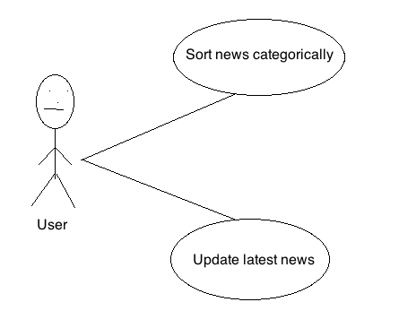

To name a few requirements currently in the system, the ability to sort news categorically depending on the topic and also the ability to update the latest news into the website for users to see.

The website must also have a fast response time in all sections of the news website. In order to meet the requirements stated above, having a reliable server with a fast connection is a must. Also, having backup servers in case of outage on the main server will ensure that the news website will be up and running always.

.

DESIGN METHODS

LIFE CYCLE MODEL

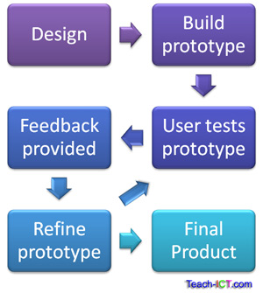

.

We are using evolutionary prototyping as our prototype method. The reason for this is because we have not discarded the previous prototype and used it as the basic for the next iteration of the design. The prototype is describing the appearance of the interface across multiple platforms.

After reviewing the prototyping model and implementing it into our design we were able to improve the different interfaces. Since a working model of the system is already provided, we as users can get a better understanding of the system in development. This allowed us to easily identify missing functionality and improve in these areas. It also gave us the opportunity to identify confusing or difficult areas that users may struggle with and improve upon them.

COGNITIVE FRAMEWORKS

Users develop an understanding of the system through learning and using it. When a user reaches the homepage they will be met with main headlines and images related to the article. Their next option would be to choose a category from the navigation bar or follow one of the main headlines to a full article. Most users would be familiar with the layout as there are many sites relatively similar with the same functions.

In our application visual metaphors can be used to describe a news headline in the form of a cartoon or an image of a small football, which can be clicked to direct the user to the football category.

INTERACTION STYLES

The interaction style we have chosen is direct manipulation. Objects of interest are visible and user actions involve selecting, opening, closing and zooming actions on virtual actions. Some of the advantages using this style are it is easy to learn and remember, reduces errors as little can go wrong and users experience less anxiety with a sense of confidence and control in what they are doing.

INPUT AND OUTPUT DEVICES

Current input devices are keyboard, mouse, and touchpads while output devices that will be used are computers, tables, and mobile phones. The reason many platforms are used as input and output devices is because nowadays people have so many options on how to get the latest news. By using various output and input devices, users have alternative options on how they want to use the system depending on what situation they are in.

UBIQUITOUS DESIGN

We consider our chosen as a very common thing that people use as it is a website that people need to get themselves up to date to the latest news around the world. With that, we consider our system to be something that has a large user group.

One thing that we decided in order to make sure that people interact with the website is by making it mobile friendly and creating a native app in the tablet and mobile platform. That will allow users to visit the website and read the latest news wherever they are and whatever situation they might be in.

EVALUATION METHODS

We will evaluate the prototype in a few phases, first with internal testing within the Team, and then invite a few people in every user group that will then give feedback. The final phase would be to live test it and then allow people that use the website to fill in a survey and feedback about the current design/features.

Using Google form to document our evaluations allows us to easily make survey/feedback forms.

PROTOTYPES

LOW FIDELITY PROTOTYPE

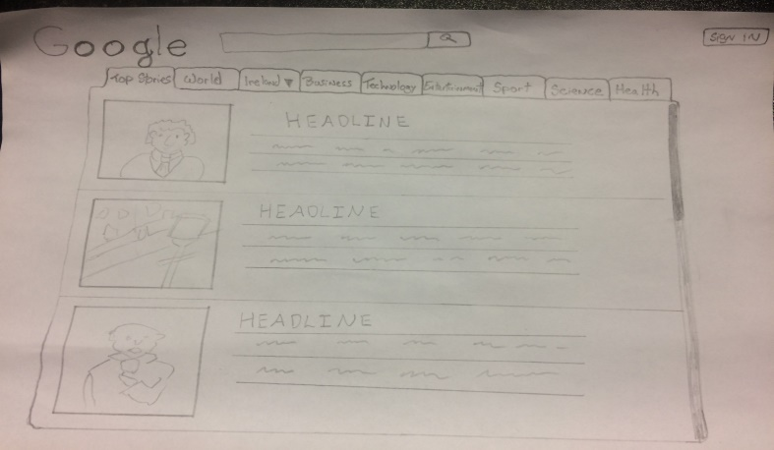

ENHANCED LOW FIDELITY PROTOTYPE

Website

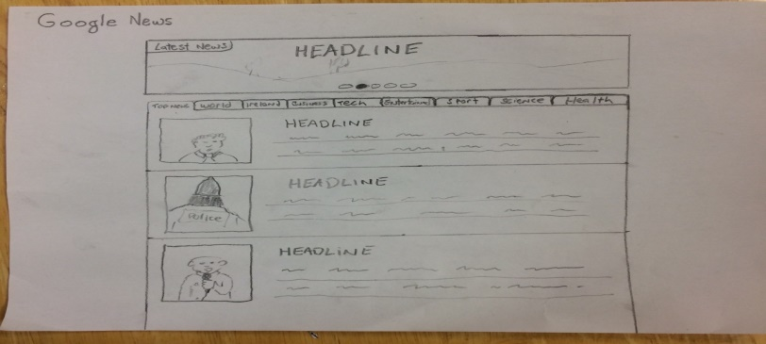

Tablet and Mobile Phones

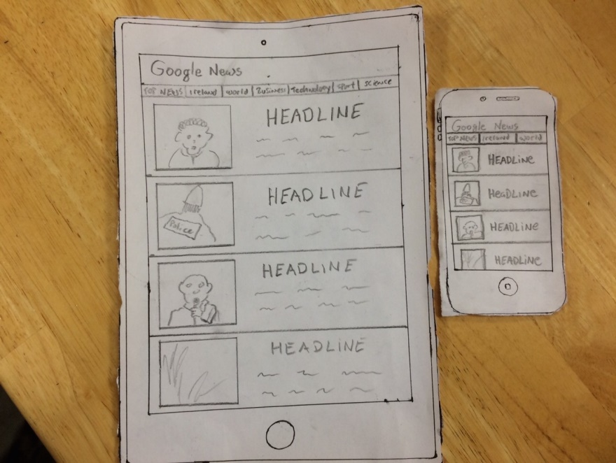

EVALUATION OF LOW FIDELITY PROTOTYPE

***Low Fidelity Prototype*** - The changes made with the current system where the foundation of the layout is based on text we would introduce more eye-catching images along with main headlines where the user can then click on the image to be directed to a more detailed article.

Enhanced Low Fidelity Prototype - Some improvements made from the previous low fidelity prototype is that there is now a headlines section at the top of the screen which is where the latest and/or top stories will be shown as a slideshow and users can click it if they are interested in reading that specific story.

We’ve also created a design the website for Tablet and Mobile phone platform to allow users with more option on how they want to read the latest news. The noticeable differences with the Tablet and Mobile platform is that the users can choose the category of the news by swiping left and right depending on what category they want.

MEDIUM FIDELITY PROTOTYPE

Tablet and mobile phones prototype

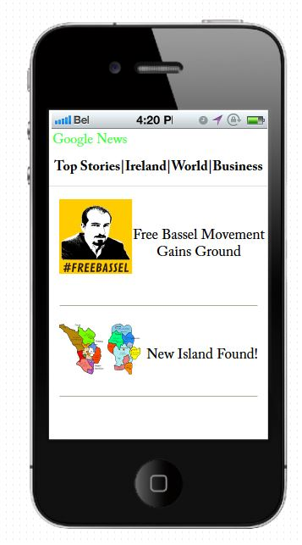

Website prototype

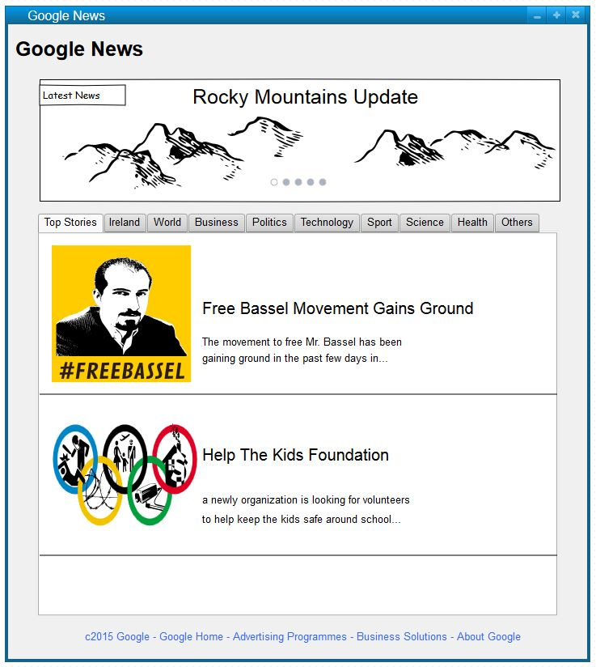

EVALUATION OF MEDIUM FIDELITY PROTOTYPE

The medium fidelity prototype looks more detailed than the low fidelity prototype made from previous weeks. Also, because it of using the pencil application, it is easier for internal testers to imagine how it would look like and can give out a better feedback.

In terms of evaluating the medium fidelity prototype, it didn’t differ substantially but rather became more detailed had took longer than the usual.

CONCLUSION

REFERENCES

[Example]

1. Custom Order Online, Inc. Available from: http://customorderwoodwindows.com [accessed November 2009].
2. All Windows Glaziers. Available from: http://www.windowglaziers.co.uk [accessed November 2009].
3. Nathan Stone Database Design - Quote Tracker: Professional Quote Management Software Available from: http://www.nathanstone.co.uk/products.html [accessed November 2009].
4. Report Writing - Example format for writing a business report. Available from:  http://www.howtobooks.co.uk/business/reports/report-writing.asp [accessed November 2008].
5. DIY Doctor Ltd - Roof Windows. Available from: http://www.diydoctor.org.uk/projects/roofwindows.htm [accessed November 2009].
6. DIY - Home Improvement, Fitting the new window frame. Available from: http://www.diynot.com/pages/wd/wd005.php [accessed November 2009].
7. MyHome.ie Residential - Selecting doors and windows. Available from: http://www.myhome.ie/residential/advice-centre/1021-1110-2516/in-the-frame-selecting-doors-and-windows.asp [accessed November 2009].
8. ForeUI - Easy-To-Use UI Prototyping Tool. Available from: http://www.foreui.com [accessed November 2009].
9. Pidoco - wireframe creation and gui prototyping tool. Available from: http://pidoco.com [accessed November 2009].
10. Prezi - The zooming presentation editor. Available from: http://prezi.com [accessed November 2009].
11. Google Docs. Available from: http://docs.google.com [accessed November 2009].
12. istartedsomething - PowerPoint Prototyping Toolkit (release 0.2). Available from: http://www.istartedsomething.com/20071018/powerpoint-prototype-toolkit-01/ [accessed November 2009].
13. Interaction Styles - HCI, Usability, Information Architecture, User Experience, and more... Available from: http://www.interaction-design.org/encyclopedia/interaction_styles.html [accessed November 2009].

EVALUATIONS

[Example]

Team performance evaluation

Our team was gathered together based on a previous team work for an assignment in the first year. All three of us know each other well. That gave us an advantage of skipping the forming phase of the team and let us to start performing more efficiently right from the beginning.

However it took a little time to realise all the requirements necessary for this assignment. We were kind of struggling with the priorities of what to focus on primarily. The work was uncoordinated especially in starting phase.

Obviously the friendly relations amongst us did not let anybody to create some stressful work environment. That might seem being a positive fact, but on the other hand it led the team to temporarily fall behind the schedule though no strict rules were set in the first place.

The performance of the team was influenced by moving between the other three main stages of team development, storming, norming and performing. That at certain stages looked like getting us off track, but in long term it definitely allowed us to come up with better ideas thanks to some storming which had occurred and stimulated even more creative environment.

Even it might seem a bit unrealistic but like last year we succeed to avoid any potential power or leadership struggles. Every member of the team experienced each of the roles which arise within the team. For any of the sub tasks once feeling being his strong point each member took the leadership naturally and the others members followed.

Thanks to knowing each other for some time and thus being aware of each other’s strengths and weaknesses we were able to split the work and delegate responsibilities to make our performance efficient.

Self-evaluation

To evaluate myself I must say working in this team was a good experience for me. I usually tend to relay on my own abilities, having some trouble to share the work and responsibilities with others. That makes me being not objective on assessing my team mates.

On the other hand I letting myself to get under an unnecessary stress because being focused into a too much detail and kind of loosing the greater picture. That is where the other team members helped me out by refocusing my concentration back on priorities.

I had as well an issue with my poor performance during the Fridays’ labs where I was not able to come out with some consistent results. I prefer a slower peace of work especially when it is important to come up with new ideas. That is why trying to concentrate most of the performance into a two hour time slot was making me uncomfortable and loosing concentration. Again being part of the team helped me to deal with this problem and, if nothing else, at least made me to carry out the minor tasks and thus stay in touch with progress. Then later when I had more time I was able to provide the ideas needed.

Peer-evaluation

The other members of the team each having his unique abilities and own work system were the necessary balance for the team to perform.

In some cases were for example two very different suggestions were pushed forward by arguing members having the third member proved to be very effective as he was able to decide which way to go. Such decisions were well accepted which helped the team to stay focused on a single target.

With the dead line closing in every member was kind of panicking at times but the rest of the team was always able to calm down any doubts about goals being achieved.